 CHEMICAL ENGINEERING TRANSACTIONS  VOL. 92, 2022 | A publication of  
The Italian Association
of Chemical Engineering
Online at www.cetjournal.it

Guest Editors: Rubens Maciel Filho, Eliseo Ranzi, Leonardo Tognotti
Copyright © 2022, AIDIC Servizi S.r.l.
ISBN 978-88-95608-90-7; ISSN 2283-9216
Economic evaluation for bioproducts production from carbohydrates obtained from hydrolysis of sugarcane bagasse
Maurino Magno de Jesus Juniorª, Fábio de Ávila Rodrigues^{b}, Marcelo Moreira da Costa^{c}, Reginaldo Guirardello^{a,*}
ªSchool of Chemical Engineering, University of Campinas, Av. Albert Einstein 500, Campinas, São Paulo 13083-852, Brazil
^{b}Department of Chemical Engineering, Federal University of Viçosa, Viçosa, Minas Gerais 36570-900, Brazil
^{c}Department of Forest Engineering, Federal University of Viçosa, Viçosa, Minas Gerais 36570-900, Brazil
Corresponding author: guira@feq.unicamp.br

The growing worldwide demand for energy and chemicals has triggered a series of academic research papers related to the conversion of carbohydrates contained in lignocellulosic biomass to biofuels and value-added substances. One of the main compounds obtained from biomass is 5-hydroxymethylfurfural (HMF), which is formed by dehydration of hexoses in acid medium and used in the synthesis of biofuels and chemicals, such as 2,5-furandicarboxylic acid, 2,5-bishydroxymethylfuran, 2,5-dihydroxymethyl-tetrahydrofuran, formic acid, and levulinic acid. HMF production from a renewable source is a promising strategy for the development of biofuels and chemicals in biorefineries. However, industrial-scale production of HMF is still limited. Therefore, this study aimed to perform a simulation and assess the economic feasibility of unit operations for HMF, levulinic acid, and formic acid production in aqueous medium using sugarcane bagasse as feedstock. Simulations of three processing steps (sugarcane bagasse pretreatment, conversion of cellulose to HMF, and product separation) were performed using Aspen Plus software version 11 (Aspen Technology Inc., USA). Economic feasibility was analyzed using equipment cost data provided by Aspen Technology and the spreadsheet proposed by Peters et al. (2003). The economic parameters assessed were return on investment, payback period, and net return. For simulations, solids yield data for the pretreatment step were obtained experimentally, reaching 56.2% with hydrothermal pretreatment and 42% with alkaline pretreatment. Chemical composition analysis of the pretreated material showed a cellulose content of 93.6%. Economic analysis indicated that the process is not economically viable. Pretreatment and product separation were the most expensive steps, accounting respectively for 43.44% and 38.6% of the total costs for equipment and installation.
  - Introduction
The processing of lignocellulosic biomass is a promising route to the development of new processes and chemicals in biorefineries (Chen et al., 2017; Li et al., 2020). Lignocellulosic biomass can be used for the synthesis of different platform molecules, such as, for example, 5-hydroxymethylfurfural (HMF), levulinic acid, formic acid, and furfural, which are used in the production of biofuels and chemicals (Chen et al., 2017). 2,5-Furandicarboxylic acid (FDCA), another compound derived from HMF, can be used as a replacement for petroleum-based compounds in the production of plastics, such as polyethylene terephthalate (PET) (Wu et al., 2016). However, the technology for HMF production on an industrial scale is still limited by its high production costs.

Production of HMF and levulinic acid is complex. In general, these compounds are obtained by acid dehydration of hexoses (Menegazzo et al., 2018). Results presented in the literature for HMF production from fructose show high yields; however, fructose represents 80% of the production cost, which limits large-scale manufacture (Torres, Daoutidis, and Tsapatsis, 2010). HMF production from glucose provides lower yields than from fructose, given the favorable thermodynamics of isomerization of glucose to fructose over the dehydration step. Furthermore, parallel steps lead to the production of undesirable compounds, such as humic compounds (Patil and Lund, 2011). HMF may also undergo rehydration, resulting in the formation of levulinic acid and formic acid (Tan-Soetedjo et al., 2017; Menegazzo et al., 2018; De Jesus Junior et al., 2022).

The literature discusses different reaction media for HMF and levulinic acid production, including different solvents, catalysts, and carbohydrate sources (fructose and glucose). However, more efficient routes to obtain HMF and levulinic acid from glucose present in lignocellulosic biomass hold great potential in biorefineries. Biomass requires previous pretreatment steps to break down its complex structure and release cellulose for downstream application as feedstock (cellulose is a source of glucose). Hydrothermal hydrolysis of biomass followed by alkaline treatment (NaOH) yields cellulose with 83% purity, whereas dilute acid hydrolysis using gamma-valerolactone/H₂O as solvent under mild conditions affords cellulose with 95% purity (Lopes et al., 2020; Alonso et al., 2017).

Sun et al. (2015) evaluated the conversion of bamboo fiber to HMF catalyzed by a solid organic acid catalyst in a two-phase H₂O/tetrahydrofuran system and obtained an HMF yield of 52.2%. Lopes et al. (2020) performed a kinetic study of the conversion of cellulose (obtained from pretreated sugarcane bagasse) to levulinic acid catalyzed by H₂SO₄, achieving a yield of 60.5 ± 2.1%. A large number of experimental studies dedicated to the production of HMF and levulinic acid can be found in the literature; however, there are few studies on process simulation or economic analysis. This study aimed to perform a simulation and technical and economic analysis of the production of HMF and levulinic acid from lignocellulosic biomass (sugarcane bagasse). This paper is divided into three sections: (i) characterization and pretreatment of sugarcane bagasse, (ii) simulation of biomass pretreatment steps, and (iii) assessment of economic feasibility.
  - Methods
    - Experimental: Pretreatment of sugarcane bagasse
Sugarcane bagasse was provided by Alcon Mill, a sugar and ethanol mill power plant located in Espírito Santo State, Brazil. Pretreatment of sugarcane bagasse consisted of two steps. The first was a hydrothermal pretreatment for hemicellulose solubilization, performed at 180 °C for 90 min using a liquid/solid ratio (dry basis) of 10:1. The second step was an alkaline pretreatment using NaOH loading of 24% (mass NaOH/sugarcane bagasse) and enough water to cover the remaining solid (8L) at 170 °C for 90 min to solubilize lignin and obtain cellulose-rich feedstock. Hydrothermal and alkaline pretreatment reactions were performed at the Pulp and Paper Laboratory of the Federal University of Viçosa, Minas Gerais State, Brazil, in a Parr reactor with a maximum capacity of 19 L equipped with a temperature control module. Agitation of the reaction medium was maintained by constant circulation of the solvent.

Sugarcane bagasse was ground in a Wiley mill and passed through 40 and 60 mesh sieves. Ground bagasse retained on the 60-mesh sieve was analyzed for chemical composition. Quantitative determination of total extractives, insoluble/soluble Klason lignin, and carbohydrates was performed according to TAPPI T264 cm-97 (280), TAPPI T280 pm-99, and chromatographic (HPLC) methods, respectively.

    - Process description
HMF production from sugarcane bagasse was simulated and analyzed using Aspen Plus software version 11 (Aspen Technology Inc., USA) in three processing steps: sugarcane bagasse pretreatment, conversion of cellulose to HMF, and product separation (Figure 1). In the pretreatment step, sugarcane bagasse is fractionated to obtain cellulose (a polymer consisting mainly of glucose monomers) as feedstock for HMF, levulinic acid, and formic acid production. Two conversion reactors (P4 and P6, Figure 1) interspersed with filters (P5 and P7, Figure 1) for separation of solid and liquid phases were used to simulate pretreatment.

The biomass processing rate was 2,000 t/day (dry basis), as proposed by the National Renewable Energy Laboratory (NREL) (Davis et al., 2013; Humbrird et al., 2011). The cellulose-to-HMF conversion step was performed in a plug flow reactor (C3) by acid catalysis at 190 °C using sulfuric acid as catalyst. The kinetic parameters and experimental conditions used in this study were based on the experiment performed by Lopes et al. (2020). The separation step consisted of four systems, affording product streams S21, S25, and S26 (Figure 1) containing formic acid (85%), levulinic acid (99%), and HMF (99%), respectively. For analysis of the separation step, a non-random two-liquid thermodynamic model was used.
    - Economic analysis
Economic assessment was performed with data for equipment costs, using Aspen Plus software and the spreadsheet proposed by Peters et al. (2003). Return on investment, payback period, and net return were estimated. The market values of raw materials were US$0.04/kg for bagasse, US$1×10⁻⁴/kg for solvent (water), US$0.58/kg for formic acid, US$5.0/kg for levulinic acid, and US$1.07/kg for HMF.

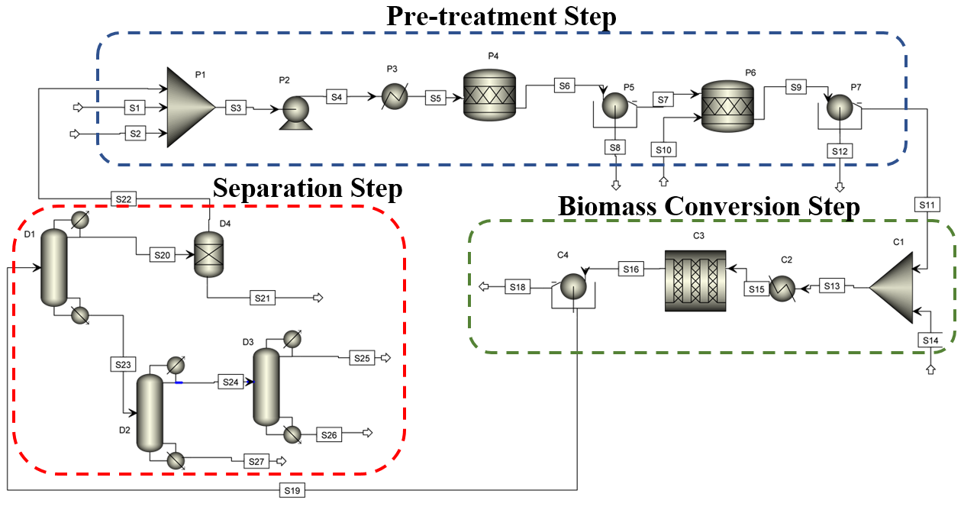
Figure 1: Process flow diagram of 5-hydroxymethylfurfural production using sugarcane bagasse as raw material.
  - Results
The main objective of the present study was to assess the conversion of sugarcane bagasse to HMF, levulinic acid, and formic acid. The simulation scenario comprised three stages and predicted the conversion of 2,000 t/day of sugarcane bagasse. The first stage consisted of sugarcane bagasse pretreatment by two methods, namely hydrothermal and alkaline, and was based on experimental results obtained by the authors. The solids yield after pretreatment was 23.5%, 56.2% of which was obtained by hydrothermal pretreatment and 42% by alkaline pretreatment. The chemical composition of sugarcane bagasse before and after pretreatment is described in Table 1.
Table 1: Chemical composition of sugarcane bagasse.
Component | Raw bagasse (% w/w) | Pretreated bagasse (% w/w)
Extractives | 6.76 ± 0.08 | -
Lignin
Soluble | 1.72 ± 0.03 | -
Insoluble | 17.8 ± 0.4 | 2.1 ± 0.2
Total | 19.6 ± 0.4 | 2.1 ± 0.2
Carbohydrates
Glucans (cellulose) | 38.0 ± 0.3 | 93.6 ± 0.6
Xylans | 20.0 ± 0.1 | 1.00 ± 0.01
Arabinans | 1.7 ± 0.07 | -
Galactans | - | -
Mannans | - | -

The simulation revealed a maximum yield of 23.5% for cellulose-rich (93.6 ± 0.6%) feedstock after pretreatment. It was estimated that HMF (99%), levulinic acid, and formic acid could be obtained at 20.4 kg/h, 9,703.96 kg/h, and 4,526 kg/h, respectively, by processing sugarcane bagasse at 2,000 t/h.

The economic feasibility study showed that the proposed process was not economically feasible. Nevertheless, it was possible to identify the most costly steps, which is crucial for the development of improved processes and products. We determined the total capital investment (pretreatment, conversion to HMF, and separation) (Figure 2A) and the costs of equipment and installation for each step (Figure 2B, C, and D).

As shown in Figure 2(A), the pretreatment step was the costliest, followed by the separation step, corresponding to 43.44% and 38.6% of the total investment cost, respectively. In the pretreatment step, the P3 exchanger had the most significant cost, followed by reactor P4 (Figure 2B). In the conversion step, reactor C3 accounted for 87.85% of the total cost (Figure 2C). For the separation step, distillation column 1 (D1) was the costliest, followed by column D3, accounting for 55.36% and 32.46% of total costs, respectively.

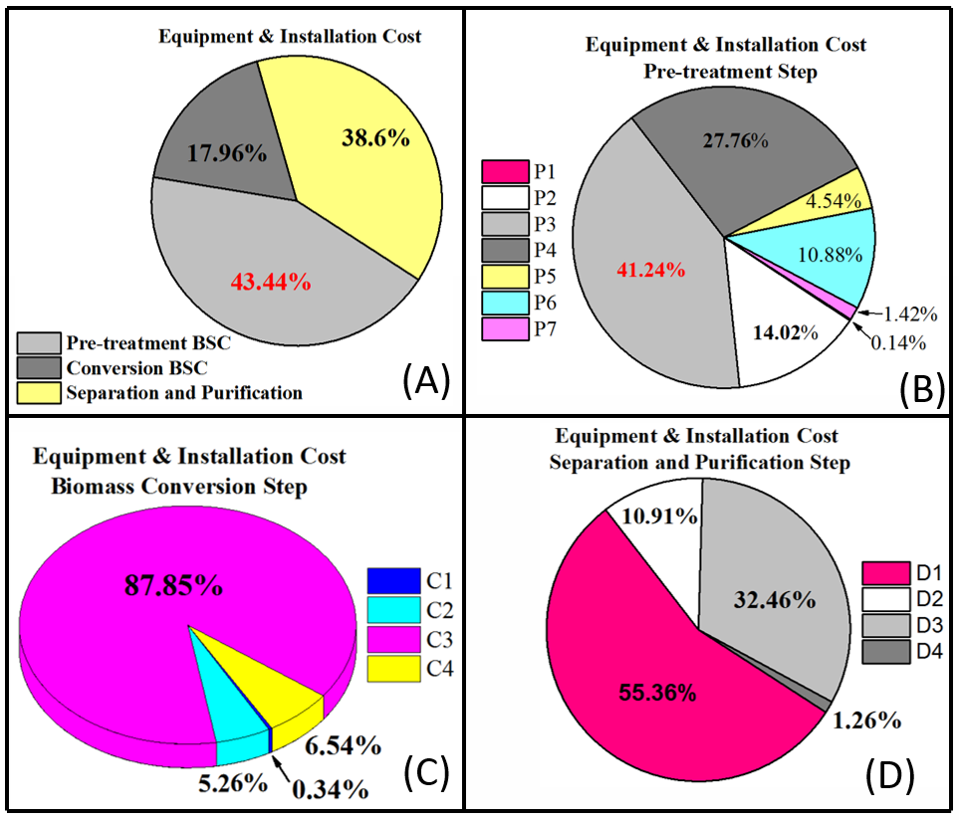
Figure 2: Equipment and installation costs of 5-hydroxymethylfurfural production from sugarcane bagasse (BSC).
  - Conclusion
Several studies have discussed the potential of using lignocellulosic biomass for the production of HMF, levulinic acid, and formic acid, as compared with other feedstock sources, such as fructose. Although lignocellulosic biomass can be used in biorefineries, there are still some challenges with regard to its application. This study assessed the feasibility of HMF, levulinic acid, and formic acid production from sugarcane bagasse. Although the biomass is a low-cost material, the process was not economically feasible; pretreatment and separation were the most expensive steps.

Acknowledgments
The authors would like to thank the Brazilian Research Agencies CAPES and FAPESP for the financial support.

References
Alonso, D. M., Hakim, S. H., Zhou, S., Won, W., Hosseinaei, O., Tao, J., Garcia-Negron, V., Motagamwala, A. H., Mellmer, M. A., Huang, K., Houtman, C. J., Labbé, N., Harper, D. P., Maravelias, C. T., Runge, T., Dumesic, J. A, 2017, Increasing the revenue from lignocellulosic biomass: Maximizing feedstock utilization. Science advances, 3(5), e1603301.

Chen, S. S., Maneerung, T., Tsang, D. C., Ok, Y. S., Wang, C. H., 2017, Valorization of biomass to hydroxymethylfurfural, levulinic acid, and fatty acid methyl ester by heterogeneous catalysts. Chemical Engineering Journal, 328, 246-273.

Davis, R., Tao, L., Tan, E. C. D., Biddy, M. J., Beckham, G. T., Scarlata, C., Jacobson, J.; Cafferty, K.; Ross, J.; Lukas, J.; Knorr, D.; Schoen, P., 2013, Process design and economics for the conversion of lignocellulosic biomass to hydrocarbons: dilute-acid and enzymatic deconstruction of biomass to sugars and biological conversion of sugars to hydrocarbons (No. NREL/TP-5100-60223). National Renewable Energy Laboratory (NREL), Golden, CO (United States).

De Jesus Junior, M. M., Fernandes, S. A., Borges, E., Baêta, B. E. L., de Ávila Rodrigues, F., 2022, Kinetic study of the conversion of glucose to 5-hydroxymethylfurfural using niobium phosphate. Molecular Catalysis, 518, 112079.

Humbird, D., Davis, R., Tao, L., Kinchin, C., Hsu, D., Aden, A.; Schoen, P; Lukas, J; Olthof, B; Worley, M; Sexton, D; Dudgeon, D., 2011, Process design and economics for biochemical conversion of lignocellulosic biomass to ethanol: dilute-acid pretreatment and enzymatic hydrolysis of corn stover (No. NREL/TP-5100-47764). National Renewable Energy Laboratory (NREL), Golden, CO (United States).

Li, M., Jiang, H., Zhang, L., Yu, X., Liu, H., Yagoub, A. E. A., Zhou, C., 2020, Synthesis of 5-HMF from an ultrasound-ionic liquid pretreated sugarcane bagasse by using a microwave-solid acid/ionic liquid system. Industrial Crops and Products, 149, 112361.

Lopes, E. S., Ccopa Rivera, E., de Jesus Gariboti, J. C., Feistel, L. H. Z., Dutra, J. V., Maciel Filho, R., Tovar, L. P, 2020, Kinetic insights into the lignocellulosic biomass-based levulinic acid production by a mechanistic model. Cellulose, 27(10), 5641.

Menegazzo, F., Ghedini, E., Signoretto, M., 2018, 5-Hydroxymethylfurfural (HMF) production from real biomasses. Molecules, 23(9), 2201.

Patil, S. K., Lund, C. R., 2011, Formation and growth of humins via aldol addition and condensation during acid-catalyzed conversion of 5-hydroxymethylfurfural. Energy & Fuels, 25(10), 4745-4755.

Peters M. S., Timmerhaus K.D., West R. E., Plant Design and Economics for Chemical Engineers. 5 ed. McGraw-Hill Education. Colorado. (2002).

Sun, J., Yuan, X., Shen, Y., Yi, Y., Wang, B., Xu, F., Sun, R., 2015, Conversion of bamboo fiber into 5-hydroxymethylfurfural catalyzed by sulfamic acid with microwave assistance in biphasic system. Industrial Crops and Products, 70, 266-271.

Tan-Soetedjo, J. N., van de Bovenkamp, H. H., Abdilla, R. M., Rasrendra, C. B., van Ginkel, J., Heeres, H. J., 2017, Experimental and kinetic modeling studies on the conversion of sucrose to levulinic acid and 5-hydroxymethylfurfural using sulfuric acid in water. Industrial & engineering chemistry research, 56(45), 13228-13239.

Torres, A. I., Daoutidis, P., Tsapatsis, M., 2010, Continuous production of 5-hydroxymethylfurfural from fructose: a design case study. Energy & Environmental Science, 3(10), 1560-1572.

Wu, L., Moteki, T., Gokhale, A. A., Flaherty, D. W., Toste, F. D., 2016, Production of fuels and chemicals from biomass: condensation reactions and beyond. Chem, 1(1), 32-5

